A

Mini Project

On

## STUDENT E-NOTES

### (Submitted in partial fulfillment of the requirements for the award of Degree)

BACHELOR OF TECHNOLOGY

In

COMPUTER SCIENCE AND ENGINEERING

By

D.SUMANTH (197R1A05K6)

G.VIDYADHARI(197R1A05L2)

E. SHIVANI (197R1A05K7)

Under the Guidance of

### RAHEEM UNNISA

(Associate Professor)



**DEPARTMENT OF COMPUTER SCIENCE AND ENGINEERING**

### CMR TECHNICAL CAMPUS

### UGC AUTONOMOUS

(Accredited by NAAC, NBA, Permanently Affiliated to JNTUH, Approved by AICTE, New Delhi) Recognized Under Section 2(f) & 12(B) of the UGCAct.1956, Kandlakoya (V), Medchal Road, Hyderabad-501401.

**2019-2023**

#### DEPARTMENT OF COMPUTER SCIENCE AND ENGINEERING



## CERTIFICATE

This is to certify that the project entitled **“STUDENT E-NOTES”** being submitted by **D.SUMANTH (197R1A05K6),G.VIDYADHARI (197R1A05L2)**and **E.SHIVANI (197R1A05K7)** in partial fulfilment of the requirements for the award of the degree of B.Tech in Computer Science and Engineering to the Jawaharlal Nehru Technological University Hyderabad, is a record of bonafide work carried out by them under our guidance and supervision during the year 2022-23.

The results embodied in this thesis have not been submitted to any other University or Institute for the award of any degree or diploma.

|  |  |
| --- | --- |
| **Raheem unnisa** | **Dr. A. Raji Reddy** |
| (Assistant Professor)  INTERNAL GUIDE | DIRECTOR |
| **Dr. K. Srujan Raju** HOD | **EXTERNAL EXAMINER** |

**Submitted for viva voice Examination held on**

### 

### ACKNOWLEDGEMENT

Apart from the efforts of us, the success of any project depends largely on the encouragement and guidelines of many others. We take this opportunity to express our gratitude to the people who have been instrumental in the successful completion of this project.

We take this opportunity to express my profound gratitude and deep regard to

my guide **Raheem unnisa,** Assistant Professor for her exemplary guidance, monitoring and constant encouragement throughout the project work. The blessing, help and guidance given by her shall carry us a long way in the journey of life on which we are about to embark.

We also take this opportunity to express a deep sense of gratitude to the Project Review Committee (PRC) **Dr. Punyaban Patel, Ms. Shilpa, Dr. M . Subha Mastan Rao & J. Narasimharao** for their cordial support, valuable information and guidance, which helped us in completing this task through various stages.

We are also thankful to **Dr. K. Srujan Raju,** Head, Department of Computer Science and Engineering for providing encouragement and support for completing this project successfully.

We are obliged to **Dr. A. Raji Reddy,** Director for being cooperative throughout

the course of this project. We also express our sincere gratitude to Sri. **Ch. Gopal Reddy,** Chairman for providing excellent infrastructure and a nice atmosphere throughout the course of this project.

The guidance and support received from all the members of **CMR Technical Campus** who contributed to the completion of the project. We are grateful for their constant support and help.

Finally, we would like to take this opportunity to thank our family for their constant encouragement, without which this assignment would not be completed. We sincerely acknowledge and thank all those who gave support directly and indirectly in the completion of this project.

**D.SUMANTH (197R1A05K6)**

**G.VIDYADHARI (197R1A05L2)**

**E.SHIVANI (197R1A05K7)**

# ABSTRACT

Now-a-days many engineering students are facing the problem with lecture notes. Mainly at the time of examinations student does not have the right platform to gain the skills. Our website (STUDENT E-NOTES) will provide the lecture notes. Here in this website all the notes are simply understandable with simple definitions, flow charts and block diagrams. But in all the websites student should search for the particular topic to gather the information required for the notes. Student cannot get the unit wise topics together. student has to visit more than one websites to learn (flow charts, diagrams, definitions).In all the diagrams, definitions etc. are provided at one platform**.**

i

## LIST OF FIGURES/TABLES

|  |  |  |
| --- | --- | --- |
| **FIGURE NO** | **FIGURE NAME** | **PAGE NO** |
| Figure 3.1 | Project Architecture for Student  E-notes | 6 |
| Figure 3.2 | Use Case Diagram for Student E-notes | 7 |
| Figure 3.3 | Class Diagram for Student E-notes | 8 |
| Figure 3.4 | Sequence diagram for Student E-notes | 9 |
| Figure 3.5 | Activity diagram for Student E-notes | 10 |

# LIST OF RESULTS

|  |  |  |  |
| --- | --- | --- | --- |
| **SCREENSHOT NO.** | **SCREENSHOT NAME** |  | **PAGE NO**. |
| Screenshot 5.1 | Home page |  | 15 |
| Screenshot5.2 | Sign up page |  | 16 |
| Screenshot 5.3 | Login page |  | 17 |
| Screenshot5.4 | User login |  | 18 |
| Screenshot 5.5 | Upload notes |  | 19 |

## TABLE OF CONTENTS

**ABSTRACT** i

**LIST OF FIGURES** ii

**LIST OF RESULTS** iii

### 1. INTRODUCTION 1

1.1 PROJECT SCOPE 1

1.2 PROJECT PURPOSE 1

1.3 PROJECT FEATURES 1

### 2. SYSTEM ANALYSIS 2

2.1 PROBLEM DEFINITION 2

2.2 EXISTING SYSTEM 2

2.2.1 DISADVANTAGES OF THE EXISTING SYSTEM 2

2.3 PROPOSED SYSTEM 3

1. 3.1ADVANTAGES OF PROPOSED SYSTEM 3
   1. FEASIBILITY STUDY 3
      1. ECONOMIC FEASIBILITY 4
      2. TECHNICAL FEASIBILITY 4
      3. BEHAVIRAL FEASIBILITY 4
   2. HARDWARE & SOFTWARE

REQUIREMENTS 5

* + 1. HARDWARE REQUIREMENTS 5
    2. SOFTWARE REQUIREMENTS 5

### 3. ARCHITECTURE 6

3.1 PROJECT ARCHITECTURE 6

3.2 DESCRIPTION 6

3.3 USE CASE DIAGRAM 7

3.4 CLASS DIAGRAM 8

3.5 SEQUENCE DIAGRAM 9

3.6 ACTIVITY DIAGRAM 10

**4. IMPLEMENTATION** 11

4.1 SAMPLE CODE 11

### 5. RESULTS 15

### 6. TESTING 20

6.1 INTRODUCTION TO TESTING 20

6.2 TYPES OF TESTING 20

|  |  |  |  |  |  |  |  |  |
| --- | --- | --- | --- | --- | --- | --- | --- | --- |
| 6.2.1 UNIT TESTING |  |  |  |  |  |  |  | 20 |
| 6.2.2 INTEGRATION TESTING |  |  |  |  |  |  |  | 20 |
| 6.2.3 FUNCTIONAL TESTING |  |  |  |  |  |  |  | 21 |
| 6.3 TEST CASES |  |  |  |  |  |  |  | 21 |
| 6.3.1 CLASSIFICATION |  |  |  |  |  |  |  | 21 |
| **7. CONCLUSION & FUTURE SCOPE** |  |  |  |  |  |  |  | **22** |
| 7.1 PROJECT CONCLUSION |  |  |  |  |  |  |  | 22 |
| 7.2 FUTURE SCOPE |  |  |  |  |  |  |  | 22 |
| **8. REFERENCES** |  |  |  |  |  |  |  | 23 |
| 8.1 REFERENCES |  |  |  |  |  |  |  | 23 |
| 8.2 GITHUB LINK |  |  |  |  |  |  |  | 23 |

**1. INTRODUCTION**

### 1. INTRODUCTION

**1.1 PROJECT SCOPE**

This project is titled "STUDENT E-NOTES". This project is used to gain knowledge from website where student can get class notes from the documents or pdfs present in the website. This documents are verified by the admin.

**1.2 PROJECT PURPOSE**

This project has been developed for students. Students can easily go through the notes and can gain the knowledge. This makes students easier to search the topics in their syllabus. The main purpose of our website is to provide the complete unitwise notes which is sorted in the simplest way which is easily understandable and he/she can get the complete notes at one platform instead of visiting the many websites.

**1.3 PROJECT FEATURES**

The main feature of this project is it makes the student easier to get the notes of their academics. It saves time as student does not need to go through different websites in search of topics. They can refer the website and can get topics in a single website. Here in this website all the notes are simply understandable with simple definitions, flow charts and block diagrams. A general statement of student e-notes is to provide the simplified and understandable notes to the students. So this make easier to get the notes instead of visiting the different websites and it also has the previous question papers. Students can get the complete notes in the single platform and go through the lecture videos for easy understanding also provides the previous question papers provides the unit wise topics.

**2. SYSTEM ANALYSIS**

**2. SYSTEM ANALYSIS**

#### SYSTEM ANALYSIS

System Analysis is the important phase in the system development process. The System is studied to the minute details and analyzed. The system analyst plays an important role of an interrogator and dwells deep into the working of the present system. In analysis, a detailed study of these operations performed by the system and their relationships within and outside the system is done. A key question considered here is, “what must be done to solve the problem?” The system is viewed as a whole and the inputs to the system are identified. Once analysis is completed the analyst has a firm understanding of what is to be done.

##### 2.1 PROBLEM DEFINITION

A general statement of student e-notes is to provide the simplified and understandable notes to the students.So this make easier to get the notes instead of visiting the different websites and it also has the previous question papers.

.

**2.2 EXISTING SYSTEM**

There are many websites (geeks for geeks,tutorial point,java tutorial) in the present day but none of them provide unit wise topics.And in the existing websites the topic are not easily understandable and does not provide the familiar examples.The student cannot able to find the similar lecture notes that is explained by the faculty.The existing websites may not provide lecture videos.

**2.2.1 DISADVANTAGES OF EXISTING SYSTEM**

Following are the disadvantages of existing system:

* Not all websites will provide the lecture videos.
* We need to visit the several websites to gather information.
* Need to search for specific topic in the unit.
* Description of the topic taught by the lecturer may differ from chosen websites.

**2.3 PROPOSED SYSTEM**

Our website (STUDENT E-NOTES) will provide complete notes which provided by the college faculty with examples.If student cannot understand from the notes he/she can go through the hyper link which redirect to the lecture videos . This will be easier to students while preparing for the examinations.The main purpose of our website is to provide the complete unitwise notes which is sorted in the simplest way which is easily understandable and he/she can get the complete notes at one platform instead of visiting the many websites.To access the website the student have to login for the security purpose and misuse of data. Provides the previous question papers.

###### 2.3.1 ADVANTAGES OF THE PROPOSED SYSTEM

* Can get the complete notes in the single platform.
* Can go through the lecture videos for easy understanding.
* Provides the previous question papers
* Provides the unit wise topics.

##### 2.4 FEASIBILITY STUDY

The feasibility of the project is analyzed in this phase and a business proposal is put forth with a very general plan for the project and some cost estimates. During system analysis the feasibility study of the proposed system is to be carried out. This is to ensure that the proposed system is not a burden to the company. Three key considerations involved in the feasibility analysis:

* Economic Feasibility
* Technical Feasibility
* Social Feasibility

###### 2.4.1 ECONOMIC FEASIBILITY

The developing system must be justified by cost and benefit. Criteria to ensure that effort is concentrated on a project, which will give best, return at the earliest. One of the factors, which affect the development of a new system, is the cost it would require.

The following are some of the important financial questions asked during preliminary investigation:

* The costs conduct a full system investigation.
* The cost of the hardware and software.
* The benefits in the form of reduced costs or fewer costly errors.

Since the system is developed as part of project work, there is no manual cost to spend for the proposed system. Also all the resources are already available, it give an indication that the system is economically possible for development.

**2.4.2 TECHNICAL FEASIBILITY**

###### 

###### This study is carried out to check the technical feasibility, that is, the technical requirements of the system. Any system developed must not have a high demand on the available technical resources. The developed system must have a modest requirement, as only minimal or null changes are required for implementing this system.

**2.4.3 BEHAVIORAL FEASIBILITY**

This includes the following questions:

* Is there sufficient support for the users?
* Will the proposed system cause harm?

The project would be beneficial because it satisfies the objectives when developed and installed. All behavioral aspects are considered carefully and conclude that the project is behaviorally feasible.

**2.5 HARDWARE & SOFTWARE REQUIREMENTS**

**2.5.1 HARDWARE REQUIREMENTS:**

Hardware interfaces specify the logical characteristics of each interface between the software product and the hardware components of the system. The following are some hardware requirements.

Operating System : Windows 10 or later

Hard Disk : 512 GB

Mouse : Optical mouse

RAM : 4GB

**2.5.2 SOFTWARE REQUIREMENTS:**

Software Requirements specifies the logical characteristics of each interface and software components of the system. The following are some software requirements.

* HTML
* CSS
* Java Script
* Bootstrap
* XMAP
* APACHE SERVER
* SUBLIME TEXT EDITOR
* MYSQLi

**3. ARCHITECTURE**

**3. ARCHITECTURE**

##### 3.1 PROJECT ARCHITECTURE

This project architecture shows the procedure followed for classification, starting from input to final prediction.

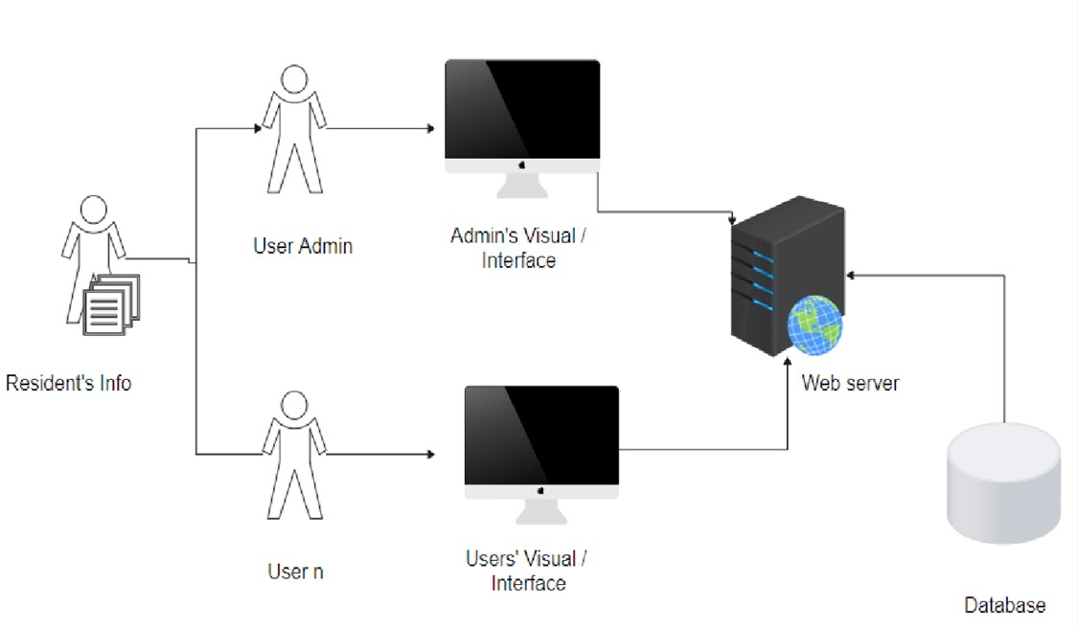

###### Figure 3.1 Project Architecture for Student E-notes

**3.2 DESCRIPTION**

This project is totally based upon providing the academic notes to the b.Tech students which is simplified and understandable.Here the student need not to visit the different websites to gather the notes.He/She can simply get the notes from single platform.And this website also consists of previous question paper which makes easier to prepare for examinations and also contains lecture videos.

**3.3 USE CASE DIAGRAM**

In the use case diagram, we have basically one actor who is the user in the trained model. A use case diagram is a graphical depiction of a user's possible interactions with a system. The actors are often shown as stick figures.

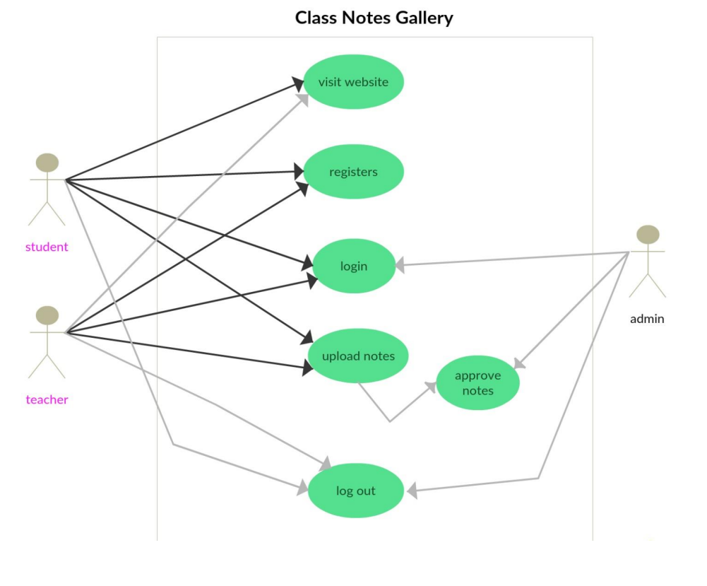

Figure 3.2 Use case Diagram for Student E-notes

**3.4 CLASS DIAGRAM**

Class diagram is a type of static structure diagram that describes the structure of a system by showing the system’s classes, their attributes, operations(or methods), and the relationships among objects.

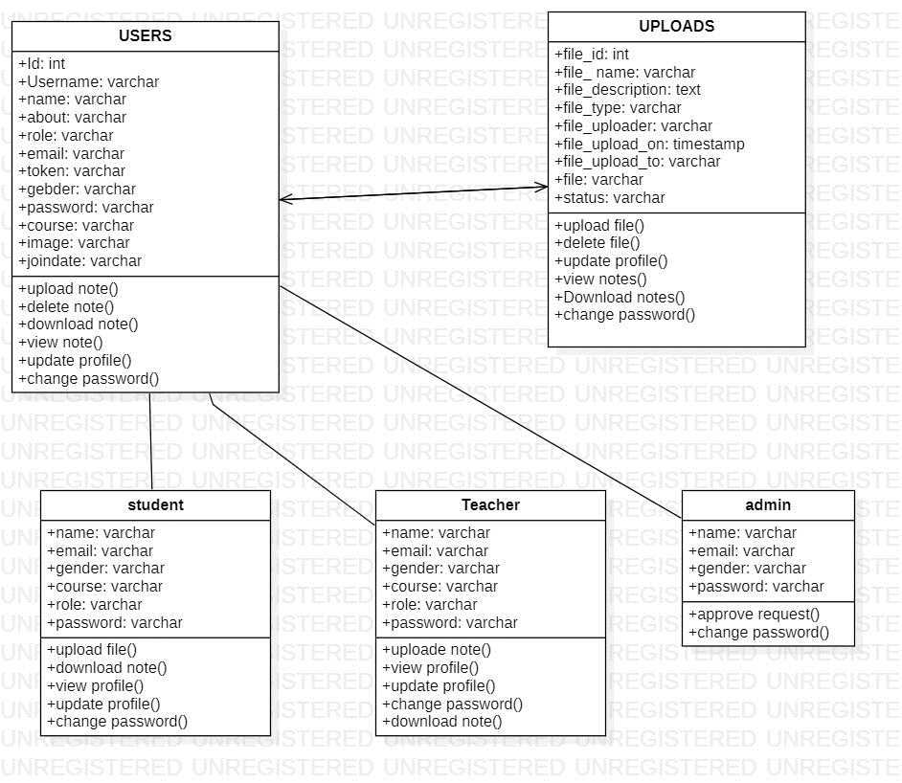

Figure 3.3:Class diagram for Student E-notes

**3.5 SEQUENCE DIAGRAM**

A sequence diagram shows object interactions arranged in time sequence. It depicts the objects involved in the scenario and the sequence of messages exchanged between the objects needed to carry out the functionality of the scenario. Sequence diagrams are typically associated with use case realizations in the logical view of the system under development.

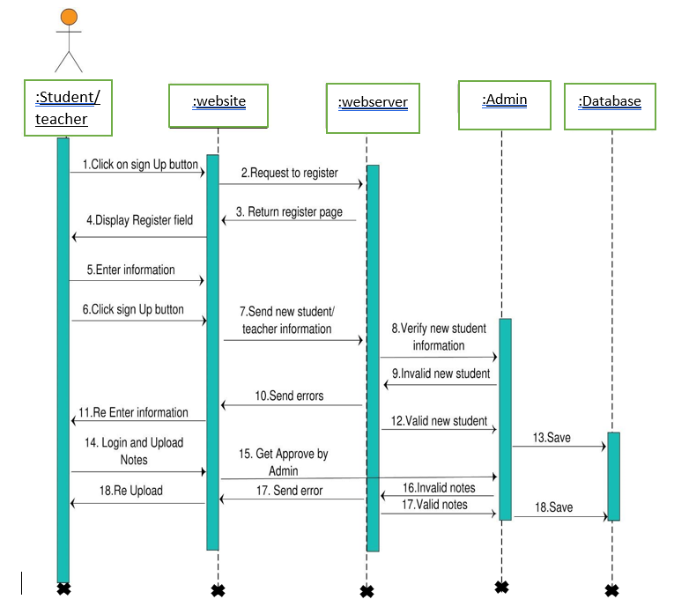

Figure 3.4: sequence diagram for Student E-notes

3.6 ACTIVITY DIAGRAM

Activity diagrams are graphical representations of workflows of stepwise activities and actions with support for choice, iteration and concurrency. They can also include elements showing the flow of data between activities through one or more data stores.

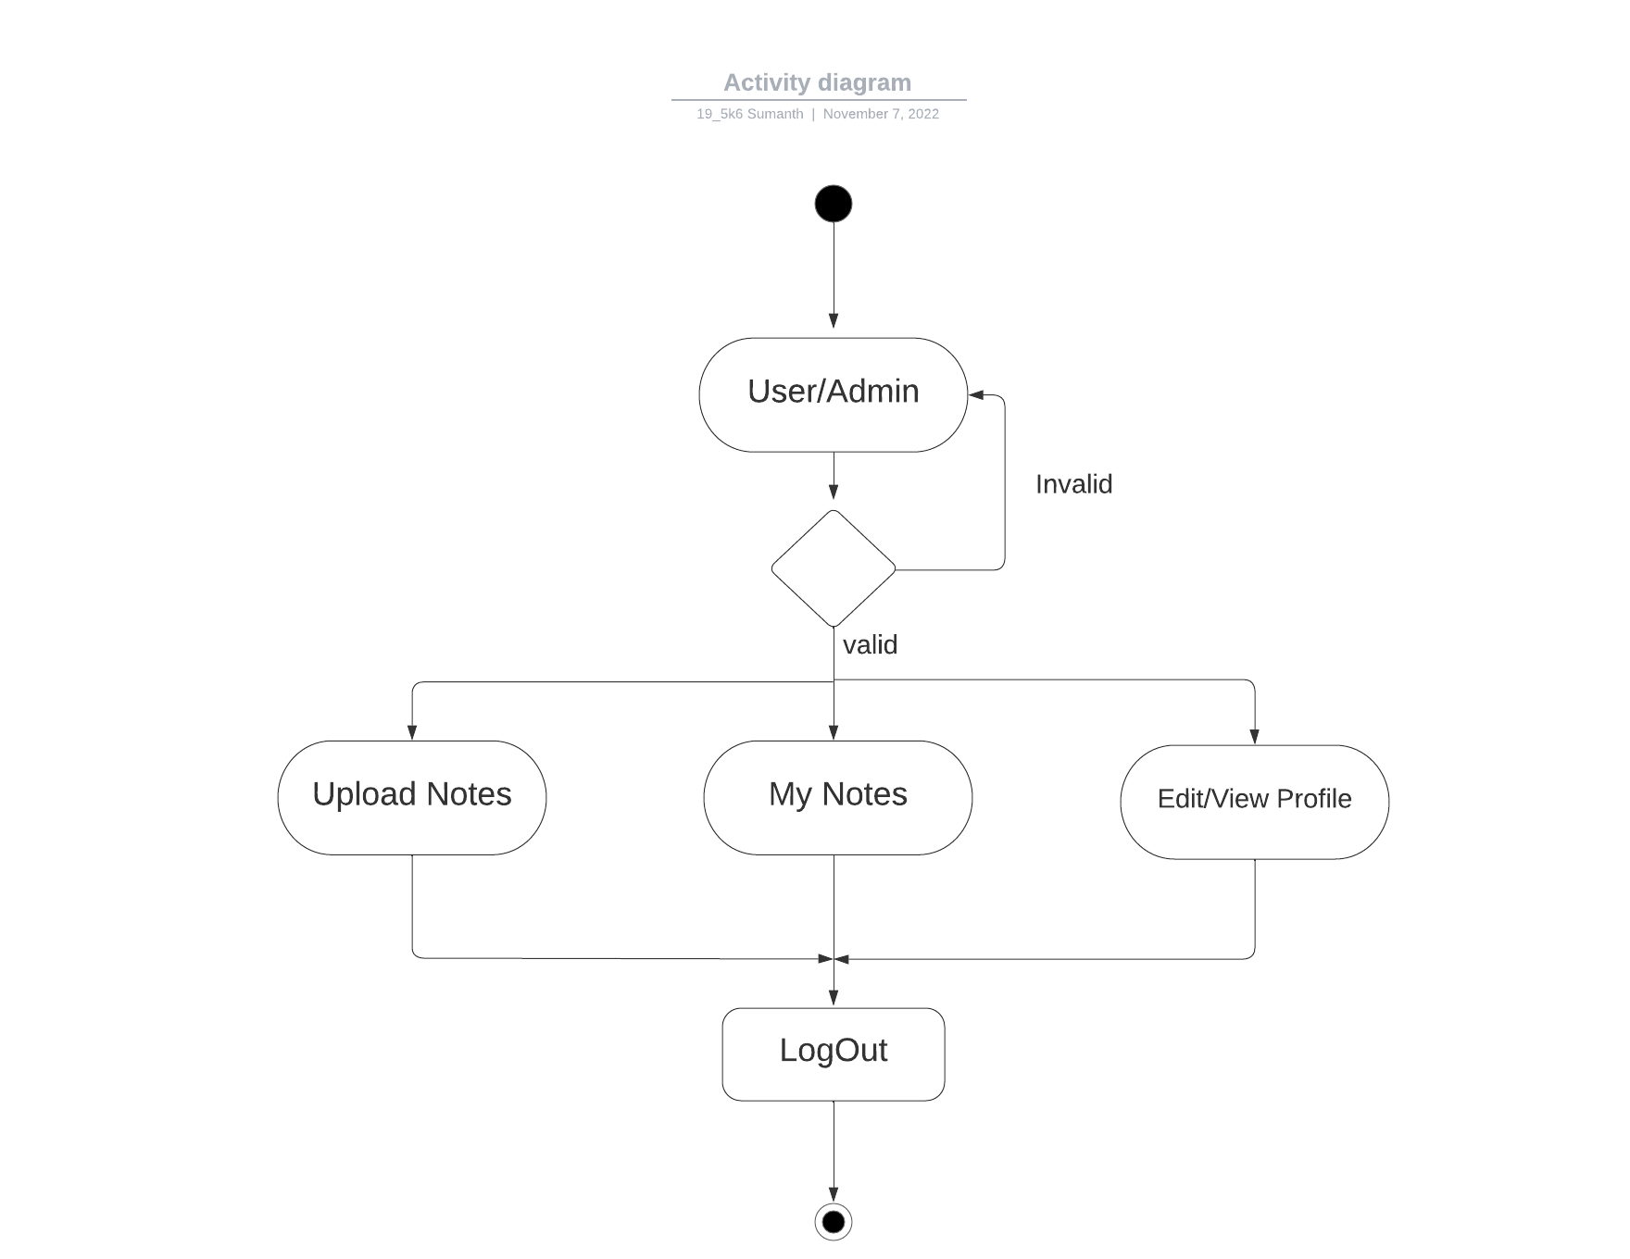

Figure 3.5: Activity Diagram for Student E-notes

**4. IMPLEMENTATION**

##### 4.1 SAMPLE CODE

nav class="navbar navbar-inverse navbar-fixed-top" role="navigation"">

<div class="container">

<div class="navbar-header">

<button type="button" class="navbar-toggle" data-toggle="collapse" data-target="#bs-example-navbar-collapse-1">

<span class="sr-only">Toggle Navigation</span>

<span class="icon-bar"></span>

<span class="icon-bar"></span>

<span class="icon-bar"></span>

</button>

<a class="navbar-brand" href="index.php">STUDENT E-NOTES</a>

</div>

<div class="collapse navbar-collapse" id="bs-example-navbar-collapse-1">

<ul class="nav navbar-nav">

<li><a href="about.php">About Us</a></li>

<li><a href="login.php">Login</a></li>

<li><a href="signup.php">Sign Up</a></li>

<li><a href="dashboard/">Upload Notes</a></li>

</ul>

</div>

</div>

</nav>

<nav class="navbar navbar-inverse navbar-fixed-top" role="navigation">

<div class="navbar-header">

<button type="button" class="navbar-toggle" data-toggle="collapse" data-target=".navbar-ex1-collapse">

<span class="sr-only">Toggle navigation</span>

<span class="icon-bar"></span>

<span class="icon-bar"></span>

<span class="icon-bar"></span>

</button>

<a class="navbar-brand" href="index">COLLEGE-NOTES-GALLERY</a>

</div>

<ul class="nav navbar-right top-nav">

<?php if($_SESSION['role'] !== 'admin') { ?> <li><a href="./uploadnote.php">UPLOAD</a></li> <?php } ?>

<li class="dropdown">

<a href="#" class="dropdown-toggle" data-toggle="dropdown"><i class="fa fa-user"></i> <?php echo $_SESSION['name']; ?> <b class="caret"></b></a>

<ul class="dropdown-menu">

<li>

<a href="./userprofile.php?section=<?php echo $_SESSION['username']; ?>"><i class="fa fa-fw fa-user"></i> Account</a>

</li>

<li class="divider"></li>

<li>

<a href="../logout.php"><i class="fa fa-fw fa-power-off"></i> Log Out</a>

</li>

</ul>

</li>

</ul>

<div class="collapse navbar-collapse navbar-ex1-collapse">

<ul class="nav navbar-nav side-nav">

<li>

<a href="index.php" class="active"><i class="fa fa-fw fa-dashboard"></i> Dashboard</a>

</li>

<?php if($_SESSION['role'] == 'admin') {

?>

<li>

<a href="javascript:;" data-toggle="collapse" data-target="#user"><i class="fa fa-fw fa-users"></i> Users <i class="fa fa-fw fa-caret-down"></i></a>

<ul id="user" class="collapse">

<li>

<a href="./users.php">View All Users</a>

</li>

</ul>

</li>

<li>

<a href="javascript:;" class="dropdown-toggle" data-toggle="collapse" data-target="#posts"><i class="fa fa-fw fa-file-text"></i> My Account <i class="fa fa-fw fa-caret-down"></i></a>

<ul id="posts" class="collapse">

<li>

<a href="./viewprofile.php?name=<?php echo $_SESSION['username']; ?>"> View Profile</a>

</li>

<li>

<a href="./userprofile.php?section=<?php echo $_SESSION['username']; ?>">Edit Profile</a>

</li>

</ul>

</li>

<?php } else { ?>

<li>

<a href="javascript:;" data-toggle="collapse" data-target="#user"><i class="fa fa-fw fa-users"></i> My Notes <i class="fa fa-fw fa-caret-down"></i></a>

<ul id="user" class="collapse">

<li>

<a href="./notes.php">View All Notes</a>

</li>

<li>

<a href="./uploadnote.php">Upload Note</a>

</li>

</ul>

</li>

<li>

<a href="javascript:;" class="dropdown-toggle" data-toggle="collapse" data-target="#posts"><i class="fa fa-fw fa-file-text"></i> My Account <i class="fa fa-fw fa-caret-down"></i></a>

<ul id="posts" class="collapse">

<li>

<a href="./viewprofile.php?name=<?php echo $_SESSION['username']; ?>"> View Profile</a>

</li>

<li>

<a href="./userprofile.php?section=<?php echo $_SESSION['username']; ?>">Edit Profile</a>

</li>

</ul>

</li>

<?php } ?>

</ul>

</div>

</nav>

**5. RESULTS**

The home page contains the sign up option where the user should sign up and contains login option where the user have to login with valid credentials.



Screenshot 5.1: Home page

The sign up page is to register for the website which gives the access to websites,where user can upload the notes with the admin approval and can download the notes.

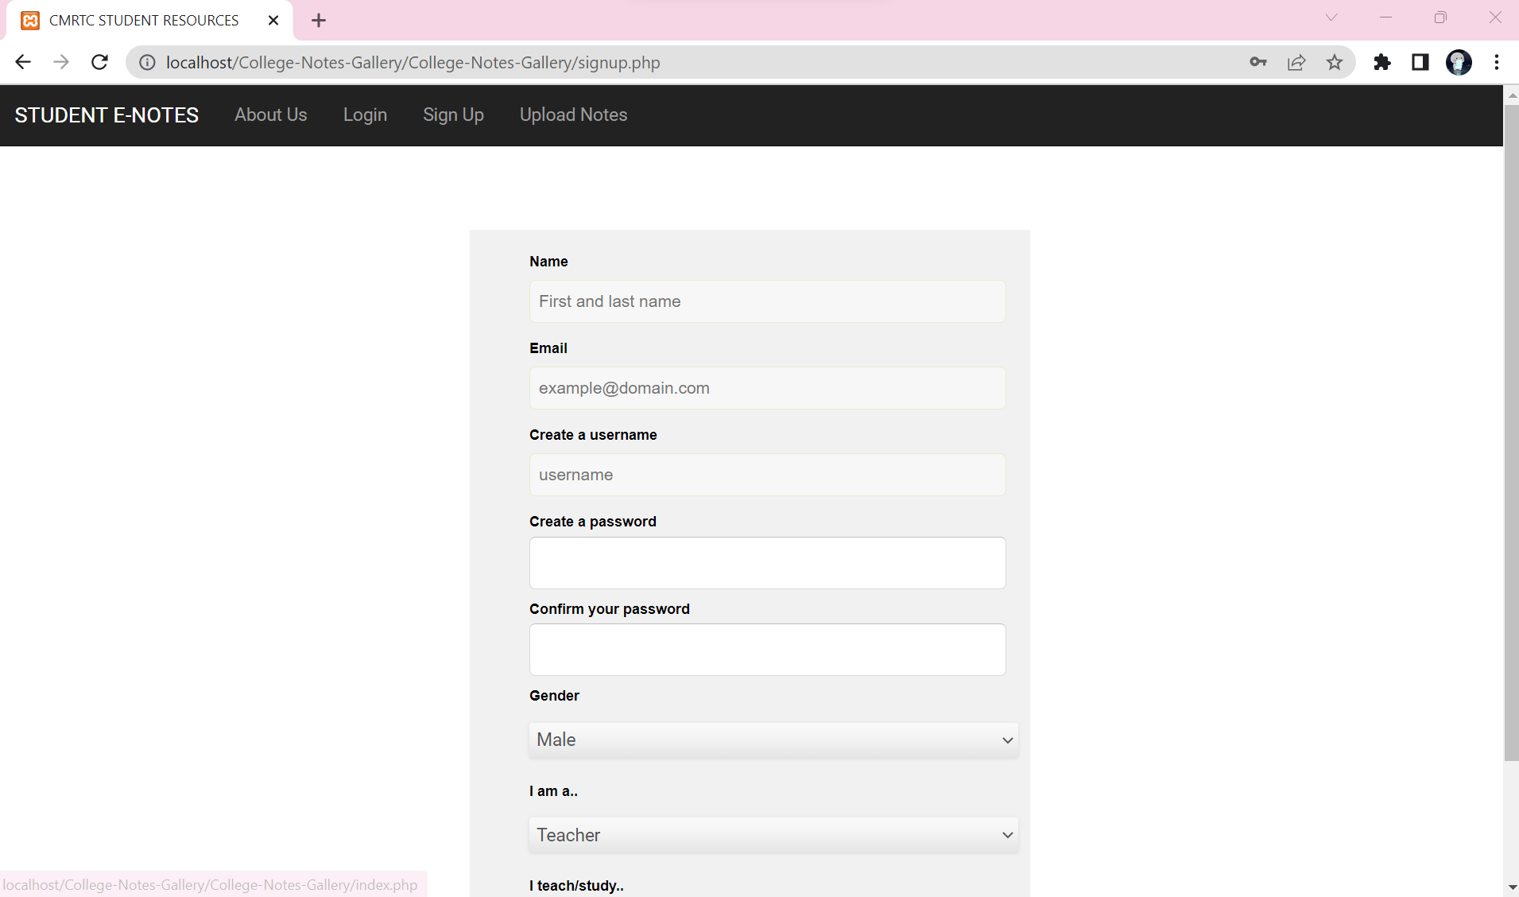

Screenshot 5.2: Signup page

In login page user have login the website with respected credentials,which gives the access to the wesite.

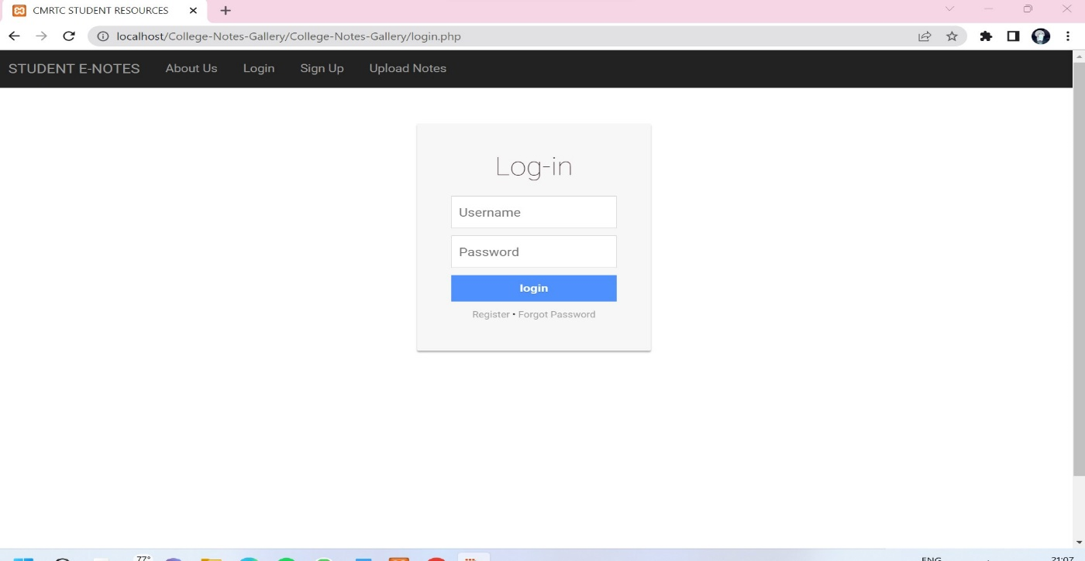

Screenshot 5.3 login page

Here the user is loging in to the website with respected credentials.If the are invalid that doesnot allow for the further process.

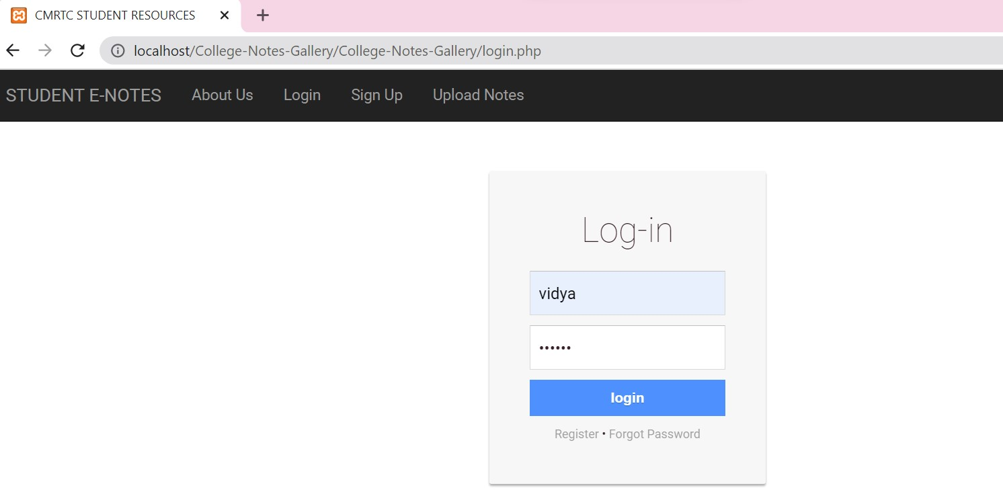

Screenshot 5.4: user login

Here the user is uploading the notes.The user can upload the notes the approval of admin.The admin will view the notes if it is related to academics then accepts the request.

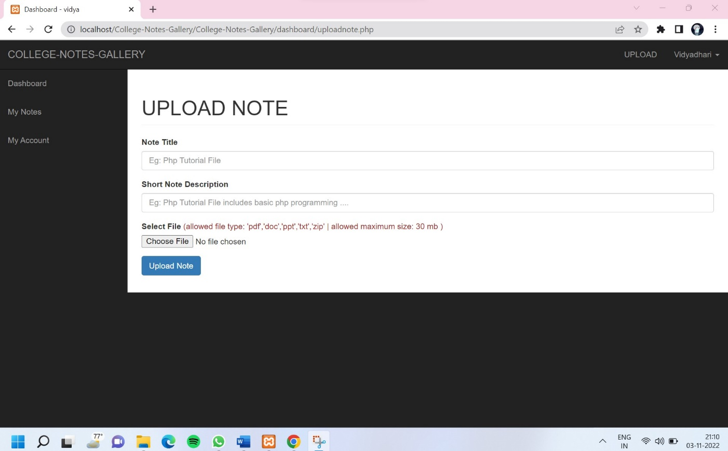

Screenshot 5.5: Upload notes

**6. TESTING**

**6. TESTING**

**6.1 INTRODUCTION TO TESTING**

The purpose of testing is to discover errors. Testing is the process of trying to discover every conceivable fault or weakness in a work product. It provides a way to check the functionality of components, subassemblies, assemblies and/or a finished product. It is the process of exercising software with the intent of ensuring that the Software system meets its requirements and user expectations and does not fail in an unacceptable manner. There are various types of tests. Each test type addresses a specific testing requirement.

#### 6.2 TYPES OF TESTING

##### 6.2.1 UNIT TESTING

Unit testing involves the design of test cases that validate that the internal program logic is functioning properly, and that program inputs produce valid outputs. All decision branches and internal code flow should be validated. It is the testing of individual software units of the application .It is done after the completion of an individual unit before integration. This is a structural testing that relies on knowledge of its construction and is invasive. Unit tests perform basic tests at component level and test a specific business process, application and/or system configuration. Unit tests ensure that each unique path of a business process performs accurately to the documented specifications and contains clearly defined inputs and expected results.

6.2.2 INTEGRATION TESTING

Integration tests are designed to test integrated software components to determine if they actually run as one program. Integration tests demonstrate that although the components were individually satisfactory, as shown by successfully unit testing, the combination of components is correct and consistent. Integration testing is specifically aimed at exposing the problems that arise from the combination of components.

##### 6.2.3 FUNCTIONAL TESTING

Functional tests provide systematic demonstrations that functions tested are available as specified by the business and technical requirements, system documentation, and user manuals.

Functional testing is centered on the following items:

Valid Input : identified classes of valid input must be accepted.

Invalid : identified classes of invalid input must Input be rejected.

Functions : identified functions must be exercised.

Output : identified classes of application outputs must be exercised.

Systems/Procedures: interfacing systems or procedures must be invoked. Organization and preparation of functional tests is focused on requirements, key functions, or special test cases.

#### 6.3 TEST CASES

**6.3.1 CLASSIFICATION**

|  |  |  |  |  |
| --- | --- | --- | --- | --- |
| Test case ID | Test case name | Purpose | Input | Output |
| 1 | User login | To view the notes | The user will login with the credentials. | The user can download the notes. |
| 2 | Admin login | To approve the request. | The admin will login and approve the request from user to upload the documents. | The user notes will be uploaded. |

**7. CONCLUSION**

**7. CONCLUSION & FUTURE SCOPE**

##### 7.1 PROJECT CONCLUSION

This project focuses on the student resources which provides the notes which is explained in class and also provides the previous question paper for reference at time of examination. If student cannot understand the notes they also go through the hyper link which will redirect to lecture videos so they will get the notes in single platform.

##### 7.2 FUTURE SCOPE

The project has a very vast scope in future. The project can be implemented on intranet in future. Project can be updated in near future as and when requirement for the same arises, as it is very flexible in terms of expansion. With the proposed software of Class Notes Gallery will be ready to use by any organisation hence run the entire work in a much better, accurate and error free manner. The following are the future scope for the project.

1-Only a particular organisation people can use this system.

2-Unique ID of students and teachers will be generated by the system.

3-Mailing system will be done with the message alert system.

**8. BIBLIOGRAPHY**

#### 8. BIBLIOGRAPHY

##### 8.1 REFERENCES

For developing this project, I have referred to many of the books and websites which gave me immense knowledge to complete my project.

Websites:

[www.stackoverflow.com](http://www.stackoverflow.com/)

[www.youtube.com](http://www.youtube.com/)

[www.w3school.com](http://www.w3school.com)

[www.google.com](http://www.google.com)

[www.slideshare.net](http://www.slideshare.net)

[www.phpbuilder.com](http://www.phpbuilder.com)

www.developer.com

Reference books : HTML and CSS by Jon Duckett.

PHP and MYSQL web development by Luke Welling, Laura.

##### 8.2 GITHUB LINK

https://github.com/197R1A05 K7/Student-E-notes

CMRTC 23